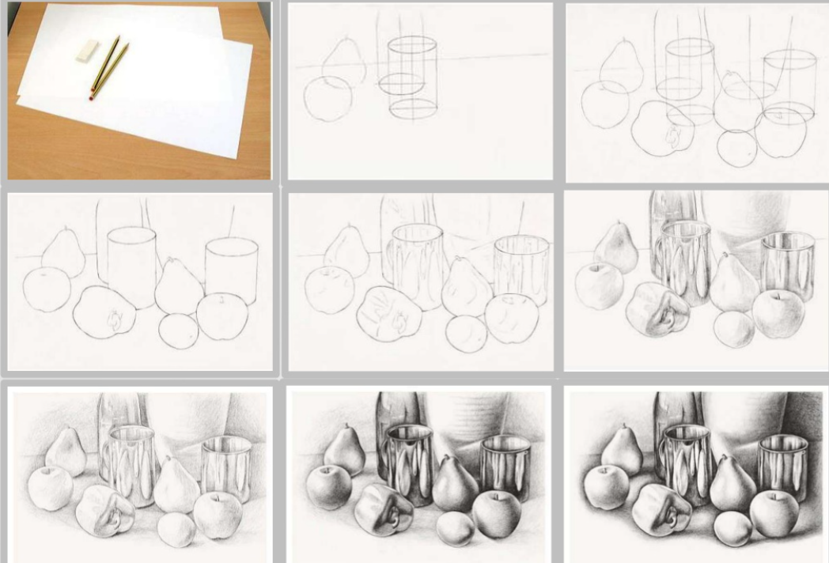
Still Life
– drawing or painting of inanimate objects such as fruit, pottery and flowers.

