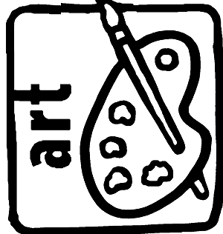AVI2O ELEMENTS OF DESIGN COLLABORATIVE POSTER
Outcome:
- Students familiarize themselves with 7 important visual art terms to further their understanding of the language essential for creating and describing visual art

Materials: Mixed media- Bristol board, markers, pencil crayons, scissors and glue
PROCESS:
- Read through the definitions of each element of design.
- Brainstorm ways in which you can visually represent what the definition is describing. Use a blank white sheet of paper to write down your ideas of what imagery you might use.
- Use a pencil to draw out your layout, which should have the title “THE ELEMENTS OF DESIGN” so that it stands out.
- Write the definition of each element near the enlarged text of each element.
- Think of a creative way to add the 7 elements (line, shape, texture etc.) to the poster board. Use interesting letters that you or your partner draws or even use text you find in magazines. Use magazine cuttings, markers and or pencil crayons to provide some imagery around each of the terms that help to explain the definitions.

RUBRIC: Elements of Design
LEVEL | R | 1 | 2 | 3 | 4
Knowledge and Understanding  - Each of the 7 definitions are included on the poster | Expectations not met | Poor/ Limited | Fair/ Some | Good | Excellent
Communication
- Student uses imagery that communicates visually the meaning expressed in the definitions for each of the elements
Thinking/ Inquiry
-Inventive, original ideas shows careful planning and thought (through following process and including brainstorming about what images to use)
-Innovative, unique artwork shows the ability to think beyond typical or usual representations of the chosen subject matter
Application/ Creation
-Artwork is creative and sophisticated
-Originality, uniqueness
-Neatness, complexity

