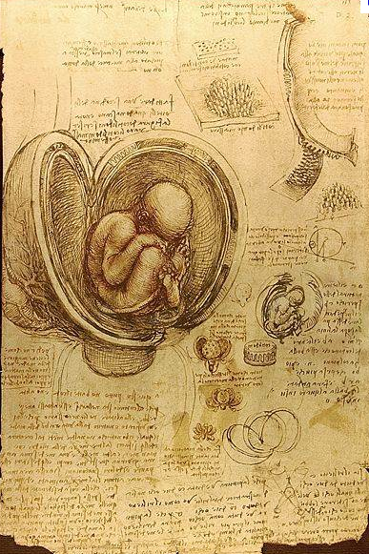

Leonardo Da Vinci’s Sketchbook page, c. 1510
A page from Leonardo’s journal showing his study of a
Fetus in the womb.

Written Critique:
Use 6 elements and principles throughout the critique:

Description:

Analysis:

Interpretation:

Judgement:
THE RENAISSANCE
The term “Renaissance” is a French term meaning “rebirth.” A new philosophy called “Humanism” developed, which felt the world, was created exclusively for humans. This philosophy taught that the human body was the outward expression of God’s perfection, and that intelligence was limitless, and as such both should be glorified. Artists used the classical style of Greece and Rome to portray this ideology in sculpture, architecture and painting.

The Top 4 Breakthroughs of the Renaissance
- Oil on Stretched Canvas. Oil on canvas became the medium of choice.
- Perspective! The method for creating the illusion of depth on a flat surface which became the foundation of European painting for the next 500 years. Linear perspective created the optical effect of objects receding in the distance through lines that appear to converge at a single point in the picture known as the vanishing point.
- Chiaroscuro – The Use of Light and Shadow. Which means “light/ dark” in Italian, referred to the new technique for modeling forms.
- Pyramid Construction- Rigid profile portraits and groupings of figures on a horizontal grid in the picture’s foreground gave way to a more 3-dimensional “pyramid configuration.”
The Renaissance Man: LEONARDO DA VINCI

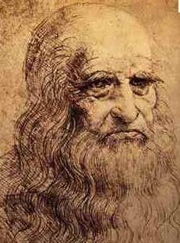
DaVinci was a master of not only painting, but mathematics, engineering, physics, botany, anatomy, geology, sculpture and architecture. He left over 10,000 pages of drawings, with accompanying notes.

Leonardo painted this masterpiece on an interior wall using an experimental mixture of oil and tempera paint. As a result, it started to deteriorate almost as soon as he was finished painting it.

Leonardo Da Vinci’s Last Supper c. 1498
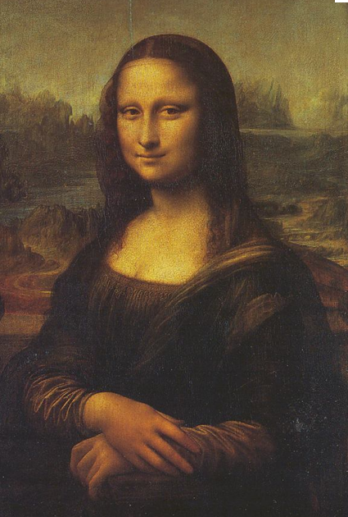
Da Vinci’s Mona Lisa c. 1503-1507


