Microsoft Publisher 2010
Create a new folder inside your BTT folder and name is Publisher. Be sure to save all exercises in this new folder. You may use the templates already provided for each exercise.
Assignment One
“Here's My Card” – Business Card
Pick your dream business and dream position! You can be anything!
- Launch MS Publisher
- Select “Business Cards”
- Select a “Template” for your business cards (Office.com Templates or Installed Templates)
- Select some different color schemes.
- Decide whether you want your business card in –“Landscape” or “Portrait” mode.
- Place a logo in the logo placeholder.
- you may create a logo or find an existing logo
- The next decision you have to make is how you want your card printed.
a) In center of page
b) Several tiled on a page
- Begin inserting information, design, etc…
- Be creative & unique !!
- Save your business card as Assignment #1 in Publisher folder
- Save as assignment #1 and show your teacher.

CRITERIA (must include)
- Your Name
- Your Title (Optional)
- Address
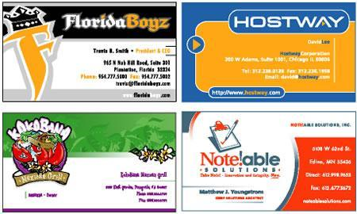
- Phone Number(s)
- E-mail Address
- Logo

Assignment Two
“Greetings”
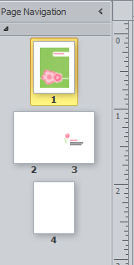
ASSIGNMENT # 2 “The Greeting Card”
- Launch MS Publisher
- Select “Greeting Cards”
- Select a “Template” for your Greeting Card
- Select some different color schemes.
- Decide which type of paper and / or fold that you want.
- Decide on what to write on the front and inside
- Begin inserting information, design, etc…
- Be creative & unique!!
- Save your greeting card as Assignment #2 and show your teacher.

CRITERIA (must include)
- Greeting of your choice
- Image on the front of the card
- Cost
- Made by
- Image on the inside folds of the card
- Image on the back of the card

Assignment Three
“It’s Party Time”
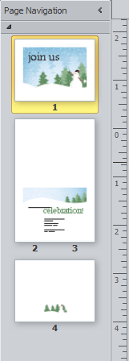
ASSIGNMENT # 3 “The Invitation”
- Launch MS Publisher
- Select “Invitation Cards”
- Select a “Template” for your card
- Select some different color schemes.
- Decide whether you want your invitation in –“Landscape” or “Portrait” mode.
- Decide whether or not you want a “Logo” placeholder.
- Begin inserting information, design, etc…
- Be creative & unique !!
- Save as assignment #3 and show your teacher.

CRITERIA (must include)
- Your Name
- The Event
- The Starting Time
- The Place
- What to Wear
- What to Bring

Assignment Four

“Congrats, You Are West Alumni”

Assignment # 4 “The Award Certificate”
1. Launch MS Publisher
2. Select the Award Certificate template
3. Scroll through the different design templates and choose the one that makes you happy
4. Pick out your color scheme
6. Put in yourself as the recipient of the certificate
7. Add your own reason for receiving the award
8. Put in today’s date
9. Add clipart or images to enhance your certificate
10. Be creative and Unique
11. Save your award as Assignment #4 and show your teacher.

Criteria
1. All relevant info
2. An interesting graphic or picture
3. It must be eye catching pleasing
4. Originality and creativity

Keep in mind if you wish you use certificate paper or plain paper

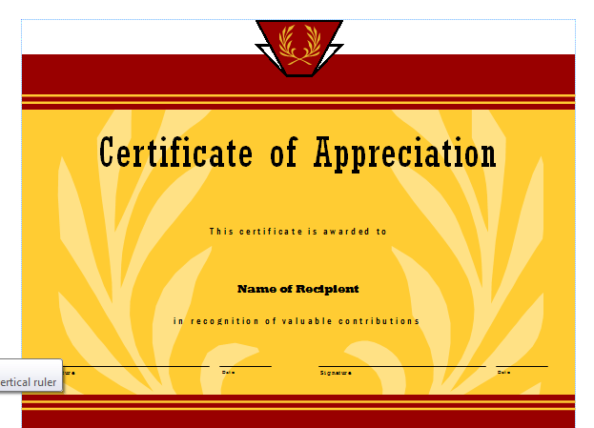

Assignment Five

“Snap, Crackle, & Pop”

Breakfast Product Advertisement
Project: You are to design an advertisement for a NEW and ORIGINAL breakfast product using Microsoft Publisher. This advertisement should be eye-catching, well balanced, and free of errors.

Requirements:
· 1 font only-You may use different sizes and colors
· 3 graphic maximum- Make sure they go with the theme of the ad
· Name the product using Word Art (watch your font choice!)
· Create a catchy slogan for the product and rotate using the custom rotate button
· Provide a short description of the product
· Create a coupon that includes a border, name of the product, amount saved, and expiration
date.
· Include either a table or bullets somewhere in your design that lists some of the selling points
of your product
· Must fit on one page only
· Save your assignment as Assignment #5 and show your teacher

Make sure you have the following before showing your teacher:

Font (one font max) | _____
Graphics | _____
Name (word art) | _____
Rotated Slogan | _____
Description | _____
Coupon (name,amount saved,date, border) | _____
Bullets/Table | _____
Spelling and Grammar | _____
Visual Effect/Design | _____

Assignment Six
“Banner”

Create a banner for a “Grand Opening”. Choose an existing business that is similar to your group business. Remember to save often! Show your teacher when completed.

You must include the following:

- Border
- Business Name, Logo, Contact Information
- Date
- Incentive
- Unique Design

Assignment Seven

“Gift Certificate/Card”

Create a Gift Certificate/ Gift Card for an existing business that is similar to your group business.
Remember to save often! Show your teacher when completed.

- Business Name, Logo, Contact Information
- Recipient Name
- Amount $
- Unique Design
- Any other important information

