Symbols The Flash-Assignment-
https://www.youtube.com/watch?v=EqxxMqCeuFQ&index=5&list=PLEQ5lBA8V3_9dwe286TgX9T-5nM82M-S3
Press F8 to put all of the parts of the character “The Flash” into The Library – F11
- Flash_Arm_Lower
- Flash_Arm_Upper
- Flash_Foot
- Flash_Head
- Flash_Leg_Lower
- Flash_Leg_Upper
- Flash_Torso
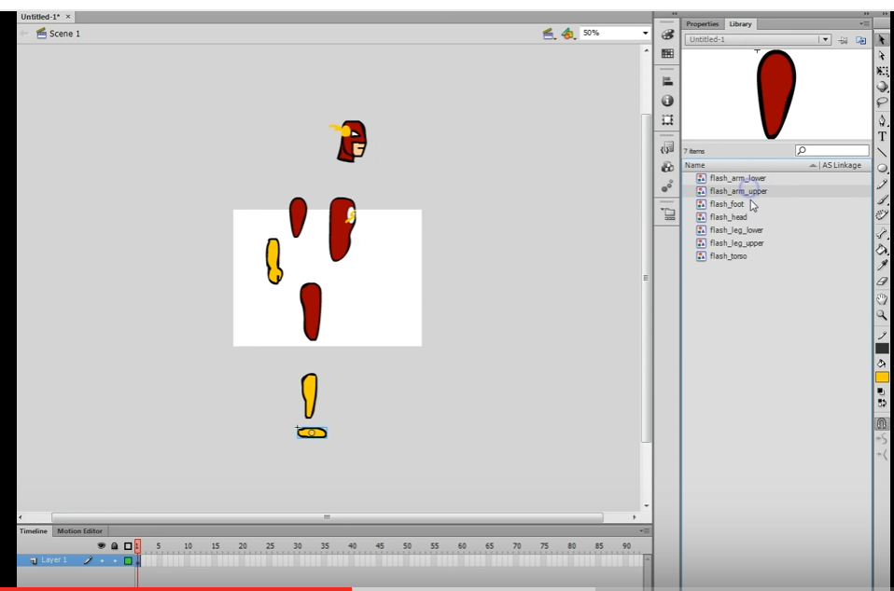

- Delete everything from the stage
- Insert new Symbol – Name it The-Flash-MC
- Build “The Flash” inside “The-Flash-MC”
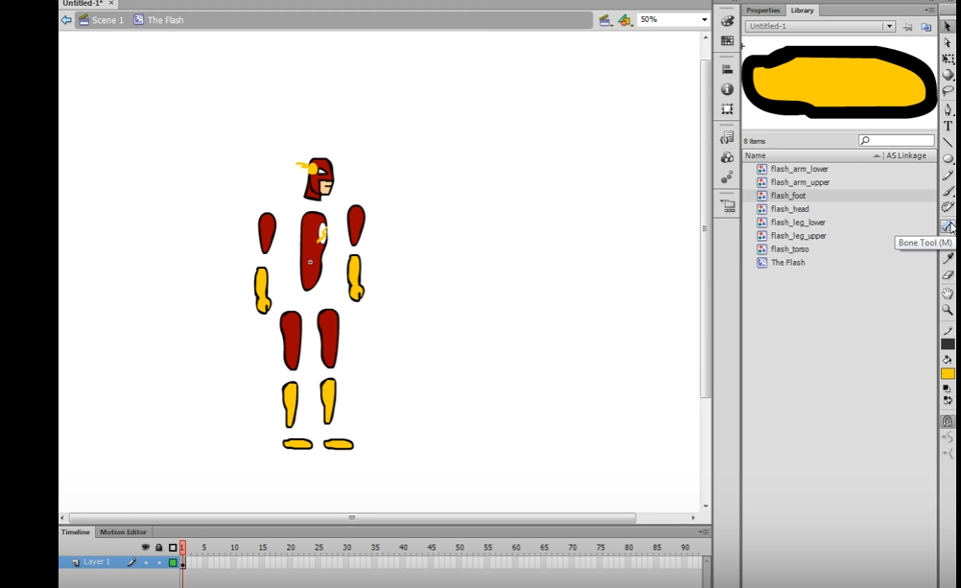

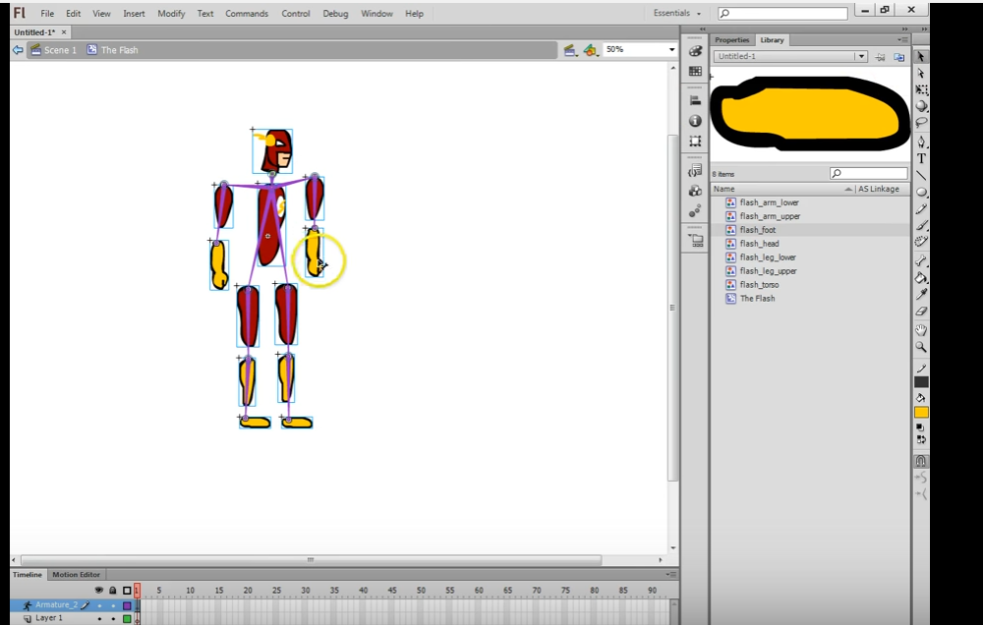

Bone Tool
Neck – Torso, Left Shoulder, Right Shoulder, Left Arm, Right Arm
Torso Upper Leg Left, Torso Upper Right Leg,
Upper Left Leg to Lower Left Leg to Lower Left Foot
Upper Right Leg to Lower Right Leg – Right Foot
- Use CTRL CLICK to Reassemble the Flash
- Use Arrange Send To Back to put the Left Leg And Left Arm to the back of The Flash Symbol
- The Flash Symbol should look like the following

