FONTS

Font: is a complete set of characters in a specific face, style and size.
It includes upper/lower case letters, numerals and punctuation.

Font Style: refers to the slant and weight of the letters (i.e. bold, italic, underline).

Font Size: refers to the height of the upper case letter in a font; size is measured in points. Note: 72 points equals one inch tall

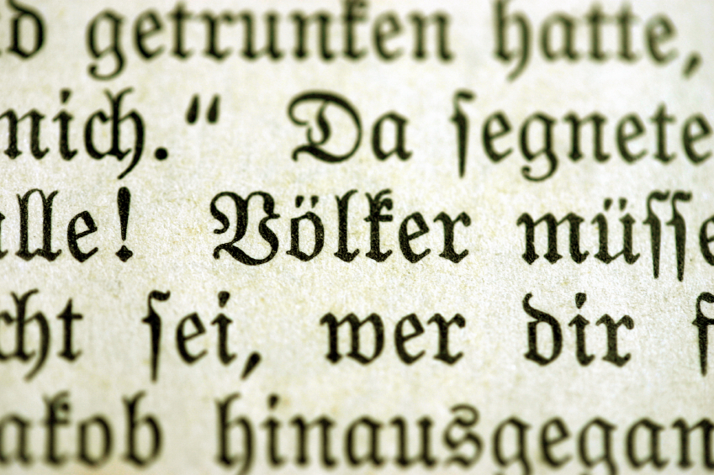

TYPES OF FONT FACES

3 Basic types of fonts:

SERIF: is a font that has curved or extended edges (serif or tail) at the end of the letter.
Times New Roman and Perpetua are examples of serif font face
Serif font is generally used in printed text as it is easier to read

SANS SERIF: is a straight-edged font
Arial and Calabri are examples of sans serif font faces
Used for headlines and technical material

SCRIPT: looks like handwriting
Brush Script MT or Lucida Handwriting are examples of script font faces
Used for formal invitations and announcements

A 4th type of font:
DECORATIVE: have embellishments such as curlicues or double lines which are designed to dress up or enhance the characters
Curlz and Chiller are examples of decorative font faces
Used very sparingly in documents

Why is the selection of font(s) important?
Font selection can set the tone in a document

How many fonts should I use one document?
More than two or three font faces makes a document look disjointed and unprofessional

