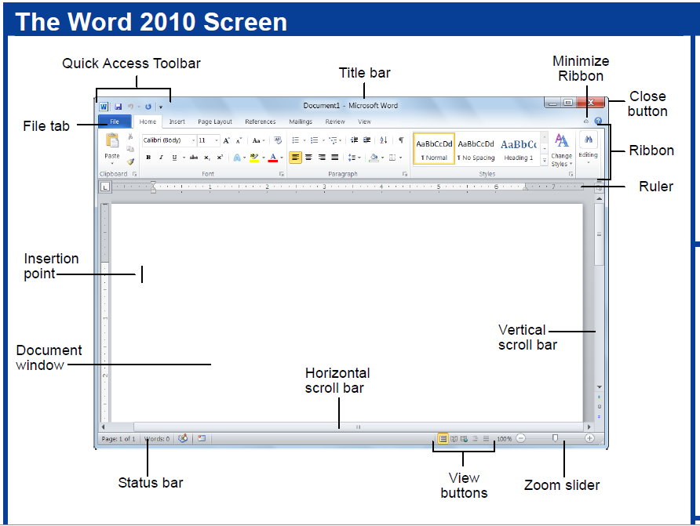

Minimize

Maximize

Group or Block