ASSIGNMENT

Using tabs and leaders, create a menu of:
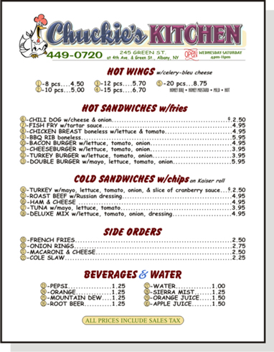
Appetizers 5
Main Dishes 10
Desserts 5
Beverages 5

Each dish needs a title, description and price.

The picture on the right is just an example, have some fun and be creative. (Check out Google images for some inspiration.)

Don’t forget a Restaurant name, and extra formatting to make your menu look great (pictures, borders, word art, shapes, etc…)

Save your file as MENU. Submit to Mr. Meissner Google Classroom.

This will be marked based on:

Use of Tabs and Leaders /8
Use of clipart/borders/word art /4
# of items included (see instructions) /4
Overall appearance /4

Application TOTAL /20

